**ARECANUT DISEASE DETECTION**

## A PROJECT REPORT

***Submitted by,***

**ROSHAN S - 20211CSD0067**

**VIDYASHREE N R – 20211CSD0203**

**CHETHAN B - 20211CSD0066**

**DARSHAN V -20211CSD0068**

**SRUSHTI M - 20211CSD0020**

**Dr. Leelambika K V**

***in partial fulfillment for the award of the degree of***

**BACHELOR OF TECHNOLOGY**

**IN**

**COMPUTER SCIENCE AND ENGINEERING**

**At**



**PRESIDENCY UNIVERSITY**

**BENGALURU, JANUARY 2025**

**PRESIDENCY UNIVERSITY**

**SCHOOL OF COMPUTER SCIENCE ENGINEERING**

**DECLARATION**

We hereby declare that the work, which is being presented in the project report entitled **ARECANUT DISEASE DETECTION** in partial fulfillment for the award of Degree of **Bachelor of Technology** in **Computer Science and Engineering**, is a record of our own investigations carried under the guidance of **Dr.Leelambika K V, Assistant Professor,** **School of Computer Science Engineering & Information Science, Presidency University, Bengaluru.**

We have not submitted the matter presented in this report anywhere for the award of any other Degree.

|  |  |
| --- | --- |
| ROSHAN S | 20211CSD0067 |
| CHETHAN B | 20211CSD0066 |
| DARSHAN V | 20211CSD0068 |
| SRUSHTI M    VIDYASHREE N R | 20211CSD0020  20211CSD0203 |

**ABSTRACT**

Arecanut is an economically vital crop whose productivity has been critically challenged by diseases like Koleroga (Mahali), Leaf Spot, and Yellow Leaf Disease. Therefore, proper diagnosis at the primary stage can be useful for effective management. This project provides a machine learning-based Arecanut plant disease prediction software with image processing and deep learning algorithms to detect and classify the diseases that are afflicting the crop. It captures images of arecanut leaves either through a mobile or web-based interface and then communicates the same to the CNNs that have been trained on a dataset of diseased and healthy arecanut plants for further processing. Its output includes detection of disease, full confidence scores, as well as recommendation of relevant treatments or preventive actions. This user-friendly interface will make easy communication between farmers, agronomists, and agricultural experts. There will be a real-time disease database so that users can update and enhance predictions based on new disease patterns. This software, therefore, helps reduce crop losses through artificial intelligence; it enhances management of diseases in crops and provides support for sustainable farming. Currently, disease detection is done purely by visual observation, and farmers must carefully analyze each crop on a regular basis to detect diseases. A picture is entered into a convolutional neural network (CNN), a deep learning algorithm, which then assigns learnable weights and biases to various objects in the image, and then, based on the outcomes, learns to differentiate between them.

**ACKNOWLEDGEMENT**

First of all, we indebted to the **GOD ALMIGHTY** for giving me an opportunity to excel in our efforts to complete this project on time. We express our sincere thanks to our respected dean **Dr. Md. Sameeruddin Khan**, Pro-VC, School of Engineering and Dean, School of Computer Science Engineering & Information Science, Presidency University for getting us permission to undergo the project. We express our heartfelt gratitude to our beloved Associate Deans **Dr. Shakkeera L and Dr. Mydhili Nair,** School of Computer Science Engineering & Information Science, Presidency University, and Dr. “Saira Bhanu”, Head of the Department, School of Computer Science Engineering & Information Science, Presidency University, for rendering timely help in completing this project successfully. We are greatly indebted to our guide **Dr. Leelambika K V, Assistant Professor** and Reviewer **Dr. Riyah Sanjaesh, Asst.Professor**, School of Computer Science Engineering & Information Science, Presidency University for her inspirational guidance, and valuable suggestions and for providing us a chance to express our technical capabilities in every respect for the completion of the project work. We would like to convey our gratitude and heartfelt thanks to the PIP2001 Capstone Project Coordinators **Dr. Sampath A K, Dr. Abdul Khadar A and Mr. Md Zia Ur Rahman,** department Project Coordinators “Ms.Manjula” and Git hub coordinator **Mr. Muthuraj.** We thank our family and friends for the strong support and inspiration they have provided us in bringing out this project.

**ROSHAN S**

**CHETHAN B**

**DARSHAN V**

**SRUSHTI M**

**VIDYASHREE N R**

**LIST OF TABLES**

|  |  |  |  |
| --- | --- | --- | --- |
| **Sl. No.** | **Table Name** | **Table Caption** | **Page No.** |
| 1 | Table 1.1 | GANTT CHART | 30 |

**LIST OF FIGURES**

|  |  |  |  |
| --- | --- | --- | --- |
| **Sl. No.** | **Figure Name** | **Caption** | **Page No.** |
| 1 | Figure 1.2 | Healthy Nut | 31 |
| 2 | Figure 1.3 | Mahali Koleroga | 31 |

**TABLE OF CONTENTS**

|  |  |  |
| --- | --- | --- |
| **CHAPTER NO.** | **TITLE** | **PAGE NO.** |
|  | **ABSTRACT ACKNOWLEDGMENT**  **…** | **4**  **5**  **…** |
| **1.** | **INTRODUCTION** | **10-12** |
|  | 1.1 Plant Disease Prediction in Arecanut |  |
|  | 1.2 Common Diseases Affecting Arecanut |  |
|  | 1.3 Need for Disease Detection Systems |  |
|  | 1.4 Technological Approaches to Disease Detection |  |
|  |  |  |
|  |  |  |
|  |  |  |
|  |  |  |
| **2.** | **LITERATURE SURVEY** | **13-14** |
|  |  |  |
| **3.** | **RESEARCH GAPS OF EXISTING METHODS** | **15-18** |
|  | 3.1 Limitations in Existing Methods  3.2 Research gaps in Existing Software Systems  3.3 Future Research Directions |  |

|  |
| --- |
|  |
| 4 | | PROPOSED METHODOLOGY | **19-20** |
| 5 | | OBJECTIVES | 21-22 |
| 6 | | SYSTEM DESIGN & IMPLEMENTATION | 23-29 |
| 7 | | TIMELINE OF EXECUTION OF PROJECT | 30 |
| 8 | | OUTCOMES | 31 |
| 9 | | RESULTS AND DISCUSSIONS | 32-34 |
| 10 | | CONCLUSION | 35 |
|  | | REFRENSES | 36 |
|  | | APPENDIX-A PSEUDOCODE | 37 |
|  | | APPENDIX-B SCREENSHOTS | 38-39 |
|  | | APPENDIX-C ENCLOSURES | 40-46 |

**CHAPTER-1**

**INTRODUCTION**

**1.1 ARECANUT DISEASE DETECTION**

Grown in tropical and subtropical regions of the world, it is a crop of significant economic importance. Many people around the world, particularly in Bangladesh, Sri Lanka, Indonesia, and India, believe that arecanut has important cultural, social, and economic qualities. India is a major contributor to worldwide arecanut production and the world's top producer and consumer. In the tropics, arecanut, also known as betel nut, is one of the most significant economic crops. It is vulnerable to numerous bacterial, viral, fungal, and insect illnesses that result in significant financial losses. Therefore, in order to provide sustainable output, early and effective care of this condition is crucial. Technology advancements in the field have opened up new opportunities for illness detection.

Mahali Disease (Koleroga), Bud Rot Disease, Stem Bleeding, Yellow Leaf Spot, and Yellow Disease are among the common illnesses that affect areca trees that are brought on by constant rainfall, climate change these illnesses need to be managed within the early stages of infection; otherwise, they could become difficult to manage later on, which could result in loss.

**1.2 Common Diseases Affecting Arecanut**

Arecanut plants are attacked by several diseases caused by fungi, bacteria, and environmental stresses. The common diseases are as follows:

**1. Koleroga (Mahali Disease):**

The illness is brought on by Phytophthora meadii. Every area where arecanuts are grown is affected by the illness. The crop losses brought on by this illness fluctuate from 10 and 90 percent according on the meteorological circumstances. Water-soaked sores on the nut surface close to the penanth end are the first visible symptoms. In extreme situations, the axis of the inflorescence and fruit stalks are also impacted. The infected nuts will often weigh less than other arecanut varieties.

**2. Stem Bleeding:**

Palms between the ages of 10 and 15 are particularly vulnerable to this illness. On the base of the stem, symptoms manifest as tiny, discoloured indentations. The fibrous fibres inside the stem eventually disintegrate as a result of these areas clumping together and cracking. A brown exudate seeps out of these fissures as the illness worsens. The palm is more susceptible to this disease when the water table is high. Thielaviopsis paradoxa is a fungus linked to this illness.

**3. Yellow Leaf Disease:**

The South-West monsoon season is when this illness is at its worst. Young palms that are under ten years old are particularly vulnerable. Usually, just three to four lower whorl leaves are infected. The symptoms start off as minor Round dots that range from brown to dark brown or black. They come in different sizes and are distinguished by a yellow halo surrounding them, which eventually develops into blighted areas. In extreme situations, the infection results in leaf loss, drooping, and drying. The pathogens causing this illness are Colletotrichum gloeosporioides and Phyllosticta arecae.

**1.3 Need for Disease Detection Systems**

The management of arecanut diseases is based on timely and accurate detection. Traditionally, farmers rely on visual inspection and expert consultations to identify disease symptoms. However, these methods have limitations, including:

Subjectivity: Human error and variability in interpretation are inherent limitations associated with visual inspection.

Delay: When symptoms become apparent, the disease may have already advanced considerably, diminishing the potential efficacy of therapeutic interventions.

Resource-Intensiveness: The process of obtaining expert consultations and performing laboratory analyses often proves to be both time-consuming and costly.

**1.4 Technological Approaches to Disease Detection**

Precision agriculture has taken the technology in agriculture to a new level, especially for disease detection. Some of the approaches used for arecanut disease detection include:

Image Processing Techniques:

High-resolution images of leaves, nuts, and stems are used to analyze discoloration, lesions, or fungal growth symptoms of diseases. These images are then processed by algorithms using pre-trained models to identify and classify diseases.

Machine Learning and Deep Learning:

Machine learning models, trained on large datasets of diseased and healthy plant images, can predict diseases with high accuracy. CNNs have proven to be a promising approach for visual symptom detection.

Mobile Applications:

User-friendly mobile apps allow farmers to upload plant images and receive instant disease diagnoses and treatment recommendations. These technologies have improved the accuracy and efficiency of disease diagnosis and equipped farmers with applicable knowledge to make better decisions about their farm's agricultural production.

**CHAPTER-2**

**LITERATURE SURVEY**

There are numerous articles in the literature about plant disease detection, but very few about arecanuts. In his study, Dhanuja K C (2020) suggested a method for identifying arecanut illnesses by image processing and texture-based grading. About 144 samples—49 good, 49 negative, and 46 poor samples—were used by the author for testing and training. For illness detection, the K-nearest neighbour (KNN) algorithm is employed.

Manpreet Sandhu et al. (2020) created a disease detection system that uses image classification of leaves. Using a machine learning algorithm, the technology automatically finds any spots or decaying areas in the leaf. The writers took pictures of the leaf using a drone camera.

An image processing method was used in another work by Ashish Nage et al. (2019) to identify plant diseases. They created an Android app to assist farmers in recognising plant diseases. The system uses a convolution neural network (CNN) to identify the leaf illness after receiving an image of the leaves.

Swathy Ann Sam et al. 2020 conducted similar research using other algorithms, including CNN, KNN, SVM, and Decision Trees, to identify plant diseases. The system uploads a picture of a sample leaf. Proceedings of the 3rd Indian International Conference on Industrial Engineering and Operations Management, New Delhi, India, November 2-4, 2023 © IEOM Society International The algorithm will determine whether any diseases are present, and if so, the system will print the disease that was found. The accuracy of the CNN the writers utilised was approximately 86%.

Suresh and Ajit Danti (2012) proposed a method for classifying and dividing raw arecanuts. This work proposes a novel three-step method for classifying arecanuts into two color-based classes: (i) segmentation, (ii) masking, and (iii) classification. In this research, the red and green colour components of the arecanut segment are used for classification.

Ashish Nage, V.R. Raut. This paper focuses on the approach based on image processing for detection of diseases of plants. Here is this paper the author developed an Android application that helps farmers in identifying plant disease by uploading a leaf image to the system which uses a convolution neural network algorithm to identify the disease in the leaf.

Joel Hanson, Annette Joy, and Anandhakrishnan MG. This involves creating a dataset for image categorisation neural network training. The dataset was gathered from the field by hand. This study used image reprocessing, which includes noise reduction, intensity normalisation, reflection removal, and masking of certain areas of the image, to improve feature extraction. After that, a deep convolutional neural network model was trained to categorise the images using these processed ones, and numerical calculations were performed using the TensorFlow framework. According to the literature review, the authors have concentrated especially on a few general plant leaves for the purpose of detecting diseases using image processing techniques and a combination of machine learning algorithms, such as SVM, CNN, KNN, and Decision Tree, either by using camera-clicked images or by creating their own datasets. The current study's major goal is to identify the disease based on the leaves, trunk, and fruit of the plant using a convolutional neural network and an open source dataset.

**CHAPTER-3**

**RESEARCH GAPS OF EXISTING METHODS**

**1. Focus on Early Detection:**

Most of the current methods are developed to identify diseases only when they reach the advanced stages, considerably reducing the efficacy of any treatment strategies.

**2. Single-Modality Studies:**

Existing studies use only one of the data sources-such as images and/or sensor data-instead of multiple modalities for better accuracy.

**3. Inadequate Consideration of Local Variability:**

The models don't acknowledge regional differences in arecanut cultivation practices, soil conditions, and climate variations.

**4. User-Centric Design:**

There are very few solutions keeping the usability for farmers in mind, like mobile-friendly interfaces or interfaces supporting local language.

**5. Insufficient Real-World Validation:**

Most of the proposed methods are evaluated only under controlled conditions rather than in real-world plantation setups.

**6. Training Data Imbalance:**

Disease datasets often exhibit imbalance with regard to the number of samples for different diseases, leading to biased models.

In many nations around the world, the cultivation of arecanuts, scientifically known as Areca catechu, plays a vital role in the agricultural economy. A number of diseases can affect arecanut plantations, including Koleroga, also known as Mahali disease, Yellow Leaf Disease, or YLD for short, and other serious diseases like Bud Rot and Root Rot. These diseases pose a serious threat to arecanut plantations in countries like India, Bangladesh, Sri Lanka, and Indonesia, where arecanut cultivation is the main source of income and a means of subsistence. It is important to remember that, despite the fact that a lot of research has been done to create efficient models for predicting diseases in arecanut plants, there are still a lot of holes and defects in the current approaches and software implementations.

**1. Limitations in Existing Methods of Arecanut Disease Prediction**Different approaches have been used in an attempt to predict diseases that may affect arecanut plants. These include traditional methods that involve manual inspection by farmers, image processing-based techniques that rely on digital images for analysis, and machine learning (ML)-based models that use advanced algorithms to interpret data. However, each of these methods has certain limitations and shortcomings, which in turn leads to a significant gap in research.

**1.1Traditional Techniques (Visual Inspection)**The conventional method of disease detection is visual inspection by the farmer or the agricultural expert. Though this method has been in practice for many years.

**2. Research Gaps in Existing Software Systems for Arecanut Disease Prediction:**

Most existing software systems for plant disease prediction are not tailored for arecanut plantations. Most of the existing models are generic.

The major research gaps are enumerated as follows. **2.1 Lack of End-to-End Automation**Most of the existing systems focus only on the task of image classification and do not consider other critical and relevant factors that could make them more effective. Some of these factors include, but are not limited to, soil quality, changing weather conditions, and patterns of disease occurrences over time. To date, there is a glaring lack of any fully automated system that can assimilate input from a variety of diverse sources and precise predictions regarding potential disease outbreaks.

**2.2 Inadequate Real-Time Monitoring and Prediction**Most of the existing solutions available in the market are fundamentally based on static image classification methodologies rather than using dynamic real-time monitoring techniques.

**2.3 Lack of Mobile-Friendly Applications**The targeted farmers are small-scale farmers, who do not have access to complicated AI-based software. There is a need for mobile-friendly applications with user-friendly interfaces that can send disease alerts through text messages or voice messages.

**2.4 Poor Integration with Expert Systems**Currently, the solutions provided do not utilize expertise and databases that present treatment recommendations Hybrid systems based on AI driven predictions and further validation by an expert are a necessity.

**2.5 Underutilization of Disease-Specific Research**Many models generalize detecting plant diseases instead of focusing on disease-specific arecanut diseases. Research on various environmental conditions in relation to diseases, such as humidity, rainfall, and pH levels of soil, is insufficient.

**3.Future Research Directions That Bridge the Gap**The future work will bridge the gaps identified in existing research in the following: **3.1 Holistic Disease Prediction System**Multimodal system based on image processing, sensor data, and expert knowledge.  
AI-based mobile applications for real-time monitoring of diseases.  
Cloud-based solution for large plantations.

**3.2 Advanced Deep Learning Models**Transformer models and Vision Transformers (ViTs) for improvement in image-based disease detection. Federated learning to support on-device disease prediction without privacy issues with data.

**3.3 Explainable AI for Farmer-Friendly Predictions**Designing AI models that give explanations for their predictions. Developing disease prevention recommendations based on AI insights.

**3.4 Creation of an Arecanut-Specific Dataset**A public dataset with a diverse set of images of arecanut diseases across different regions. Annotated datasets for the development of supervised learning models. Computing should be developed to address these gaps. Future research must focus on developing automated, scalable, and farmer-friendly solutions to ensure early detection of diseases and improvement in the yield of arecanut crops.

**CHAPTER-4**

**PROPOSED MOTHODOLOGY**

The project consists of two parts:

• Dataset collection

• Training a neural network model for the prediction of plant diseases.

Datasets: We have developed a dataset of both healthy and diseased photos of arecanuts and their leaves in order to identify different arecanut illnesses. A digital camera was used to capture the pictures from a half-meter away from the source. Images of both healthy and ill arecanuts were gathered from Shigga in the Karnataka region of Shimoga. Experienced arecanut farmers and experts verified the authenticity of the photos. There are 620 photos in all, showing both healthy and unhealthy arecanut leaves, nuts, and trunks. There are 420 pictures of arecanuts with diseases including yellow, yellow spot, Mahali/Koleroga, and stem bleeding illness, and 200 pictures of arecanuts in good condition. Using open-cv libraries, the photos are resized to 256px × 256px in order to prepare them for model training.

Convolutional Neural Networks, also known as CNNs, are deep learning algorithms that can take an image as input, give distinct characteristics of the image weights and biases, learn from the findings, and distinguish one feature from another. Compared to other classification methods, it requires less pre-processing. ConvNets might learn these filters/characteristics with a lot of training, whereas earlier approaches created filters based on specifications. We demonstrate our model's functional design on this account.

Preprocessing: Images were resized, reshaped, and converted into arrays as part of the database's preprocessing. The image samples underwent the same processing. Prior to CNN training, the photographs were scaled to 256*256 resolutions.

Convert Images To Array: Resizing photos to 256*256 pixels and turning them into arrays are both included in this process. The array spans from pure RGB values of 0 to 256 since it is used to convert image modality into numeric modality.

Extensive Model Structure: Broad model structure: The convolution neural network is made up of several layers, such as Flatten, MaxPooling2D, Activation, Dense, Dropout, and Convolution2D. In order to train the CNN model, we used 1000 neurones in the first layer, 500 in the second, 250 in the third, and 5 in the final layer. The relu function activates the first three layers, whereas soft max is active in the last one. Weights and biases were included in the 248,655,647 parameters that were computed. The latter provides a chance of disease detection using a soft max activation function. An illustration of our model's tiered structure can be found below.

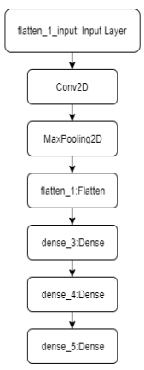

**CHAPTER-5**

**OBJECTIVES**

The objectives of an Arecanut Plant Disease Prediction software project are usually about improving crop health and yield for farmers. Here are some of the key objectives:

Early Disease Detection:

Create a system that can accurately identify various diseases affecting Arecanut plants at an early stage. Enable timely intervention and reduce crop losses.

Improved Disease Diagnosis:

Offer farmers a reliable tool for diagnosing plant diseases, even those with limited expertise.

Assisting in distinguishing among diseases that resemble each other.

Improved Crop Management:

Provide an overview of the disease trend for better management through proactive strategies

Help farmers with decisions regarding control of pests, fertilizer applications, and irrigation.

Increased Productivity and Yield:

By preventing losses of crops to diseases, the software looks to significantly improve the overall yield and profitability of Arecanut farmers.

Reduction in use of Chemical-based Pesticides:

Advocate the use of more environmentally friendly and sustainable agricultural practices through encouraging the introduction of early disease detection systems as well as the use of non-chemical means to control diseases.

User-Centric Interface:

Create an interface design that is intuitive but at the same time very easy to use. It should, therefore, be usable by farmers of any technical skills from the most inexperienced to the advanced users.

Data-Informed Decisions:

Collect and analyze rich data on diseases and their prevalence, environmental variables, and various management practices that would be very informative for guiding future research work and improving the performance of models that predict disease occurrences.

**CHAPTER-6**

**SYSTEM DESIGN & IMPLEMENTATION**

The system design and implementation of an Arecanut Plant Disease Prediction of this software, indicating the architecture as well as the key components and the technology stack and the various details of implementation. Farmers can upload images of affected leaves, stems, or nuts. The system preprocesses images (resizing, noise removal, enhancement).

Disease Classification & Detection: The system uses a trained ML/DL model for classification of plant diseases. It provides disease details and severity level. Recommendation System. Based on the detected disease, the system suggests treatment measures. Includes organic and chemical solutions.

Farmer Advisory Dashboard: Shows historical disease trends and offers advice on preventive care. It looks at Management of Users. Agronomists, researchers, and farmers by which they can sign up and log in.

Notification System: Alerts users about disease outbreaks in their area and also provides periodic disease prevention tips.

Non-Functional Requirements.  
Scalability: Support multiple concurrent users.  
Performance: Fast image processing and response time.  
Security: Secure authentication and data encryption.  
Usability: User-friendly mobile and web application.

System Architecture:

Frontend (Client Side):  
Web and Mobile UI for uploading images and viewing results.  
Technologies: React.js, Flutter

Backend (Server Side):  
It will handle all the requests, process images, run ML models, and then return predictions.

Implementation Details:

**1. Data Collection:** Images of healthy and diseased arecanut leaves and nuts are collected.  
Data augmentation techniques (rotation, scaling, noise addition) are applied.  
Labeled dataset creation for supervised learning.

**2. Model Training:** A CNN-based architecture (ResNet/EfficientNet) is trained on the dataset. Pretrained models fine-tuned with transfer learning. Model evaluation using accuracy, precision, recall, and F1-score.

**3. API Development:** Flask/FastAPI backend. The trained ML model is integrated  
RESTful API endpoints for image upload, processing, and prediction

**4. Front-end Development:** Developed web and mobile applications based on React.js and Flutter. It is User-friendly dashboard with real-time disease detection

**5. Deployment**: The ML model is deployed on Google Cloud AI/ AWS SageMaker, Backend and database hosted on AWS EC2 & Firebase, Mobile app deployed on Google Play Store & Apple App Store.

Arecanut Plant Disease Prediction software is an advanced technology integration that combines the strengths of Machine Learning, Cloud Computing, and Mobile Technologies into a quite robust solution that caters primarily to farmers. It helps in detecting diseases in their incipient stage through AI-powered techniques of image classification, thus enhancing agricultural productivity. It also serves as an excellent supporting system for the farmers in successfully performing the right

**System Overview:**The Arecanut Plant Disease Prediction System is an intelligent software application that observes environmental conditions, identifies symptoms by image recognition of leaves, and predicts the likelihood of disease occurrence. It consists of the following components:

Data Collection Module – Captures image and environmental data.  
Preprocessing Module – Cleans and preprocesses data.  
AI-based Prediction Module – Classification and prediction of diseases.  
Decision Support & Reporting Module – Provides farmer insights and recommendations.  
User Interface (UI) Module – Web and mobile-based dashboards.

**System Architecture:**The architecture of the Arecanut Plant Disease Prediction System is hybrid in nature, combining edge computing

**2.1. Layered Architecture**  
The system is composed of five layers:  
  
Layer 1: Data Collection Layer

Drones / Mobile Cameras: High-resolution images of leaves for disease detection.  
Weather API Integration: Fetching real-time and historical weather data.

Layer 2: Data Processing & Storage Layer  
Edge Processing (Raspberry Pi / Edge AI Devices): Preprocessing of data at the farm location.  
Cloud Storage (AWS S3, Google Cloud Storage): Large-scale storage of images and sensor data.  
Database Management (MySQL, MongoDB): Storing structured (sensor readings) and unstructured data (images).

Layer 3: AI-Based Prediction Layer  
Image Processing Techniques: Segmentation, feature extraction (OpenCV, TensorFlow).  
Deep Learning Model: CNN (Convolutional Neural Network) for classification.  
Machine Learning Algorithms: Decision Trees, Random Forest, SVM for tabular data-based predictions.  
Ensemble Learning: Combining multiple models to improve accuracy.

Layer 4: Decision Support & Alerting Layer  
Prediction Results Visualization: Dashboard for farmers, agronomists, and government agencies.  
Automated Alerts: SMS and app notifications for disease outbreaks.  
Recommendation Engine: Provides preventive measures and treatment suggestions.

Layer 5: User Interaction & Control Layer  
Mobile Application: Android/iOS app for farmers.  
Web Dashboard: Interactive web portal for researchers and agricultural officers.  
Voice-Based Advisory (AI Chatbot): Helps illiterate farmers understand reports.

**3. System Components & Modules**  
The system comprises several modules that operate in unison.  
  
3.1. Data Collection Module  
Utilizes high-resolution cameras or drones for collection of leaf images.  
Retrieves historical disease data from databases of agricultural research.

3.2. Data Preprocessing Module  
Image Preprocessing, Noise reduction, resizing, augmentation.  
Segmentation to identify infected areas.  
Tabular Data Preprocessing  
Handling missing values and feature scaling.  
Normalization of sensor data.

3.3. AI-Based Disease Prediction Module  
Deep Learning: CNN for Image Classification

Input: Leaf Images → Output: Class of Disease: Koleroga, YLD, Healthy  
Trained with labeled datasets by TensorFlow/ Keras / PyTorch  
Machine Learning for Environmental Analysis  
Uses Random Forest, SVM, XGBoost.  
Predicts disease probability based on climate conditions.

3.4. Decision Support System  
Provides treatment recommendations.  
Early warning alerts for high-risk areas.  
Graphical dashboards for visualization.

3.5. User Interface Module  
Web App: Provides interactive reports and graphs.  
Mobile App: Enables farmers to capture images and receive alerts.  
Chatbot & Voice Assistant: Supports regional languages.

**4. Machine Learning & Deep Learning Models**  
The core of the system is AI-based prediction.  
  
4.1. Image-Based Disease Prediction  
Uses a Convolutional Neural Network (CNN).  
Model Architecture:  
Input Layer: Resized images (e.g., 256x256).  
Hidden Layers: Convolutional + Max Pooling layers.  
Fully Connected Layer: Classification into disease categories.  
Output Layer: Softmax function for probability distribution.

4.2. Environmental Data-Based Prediction  
Uses Decision Trees, Random Forest, and XGBoost.  
Features:  
Temperature  
Humidity  
Rainfall  
Soil Moisture  
Disease Occurrence History

4.3. Ensemble Model  
Combines CNN (image-based) and ML (sensor-based) predictions for higher accuracy.

**5. Security & Privacy**  
Data Encryption (AES-256) for protecting farmer data.  
Role-Based Access Control (RBAC) for securing dashboards.  
GDPR Compliance to ensure user privacy.

**6. Benefits of the System**  
Early Disease Detection – Helps prevent large-scale crop damage.  
Increased Productivity – Farmers can take preventive actions.  
Cost Savings – Reduces pesticide misuse and unnecessary interventions.  
Automated Advisory System – Provides real-time suggestions.  
Scalability – Can be extended to other crops.

**7. Future Enhancements**  
Blockchain-based Supply Chain – Ensuring transparency in agriculture.  
AI-based Voice Assistants – Regional language support for farmers.  
Integration with Government Schemes – Link with subsidies and advisory services.

The Arecanut Plant Disease Prediction System uses the advanced capabilities of AI, Internet of Things, and cloud computing technology for a significant revolution in precision agriculture. It provides farmers with critical early warnings using complex image recognition techniques and analytics-driven sensors and real-time alerts. The system further provides practical actionable insights and effective strategies to prevent the spread of diseases among crops.  
This software benefits not only the individual interests of farmers but also the agricultural institutions, policymakers, and researchers. Thus, it plays an important role in healthy crop production and productivity on a large scale.

**8. Software Development Life Cycle (SDLC)**  
The software is developed following the Agile Methodology:  
  
Requirement Analysis – Identify farmer needs, data sources.  
System Design – Define architecture and components.  
Data Collection & Preprocessing – Build datasets.  
Model Development & Training – Train and test ML models.  
Integration & Testing – Deploy modules and perform unit testing.  
Deployment & Monitoring – Host on cloud, monitor system performance.  
Maintenance & Updates – Continuously improve based on user feedback.

**CHAPTER-7**

**TIMELINE FOR EXECUTION OF PROJECT**

**(GANTT CHART)**

**Table 1.1 Gantt chart**

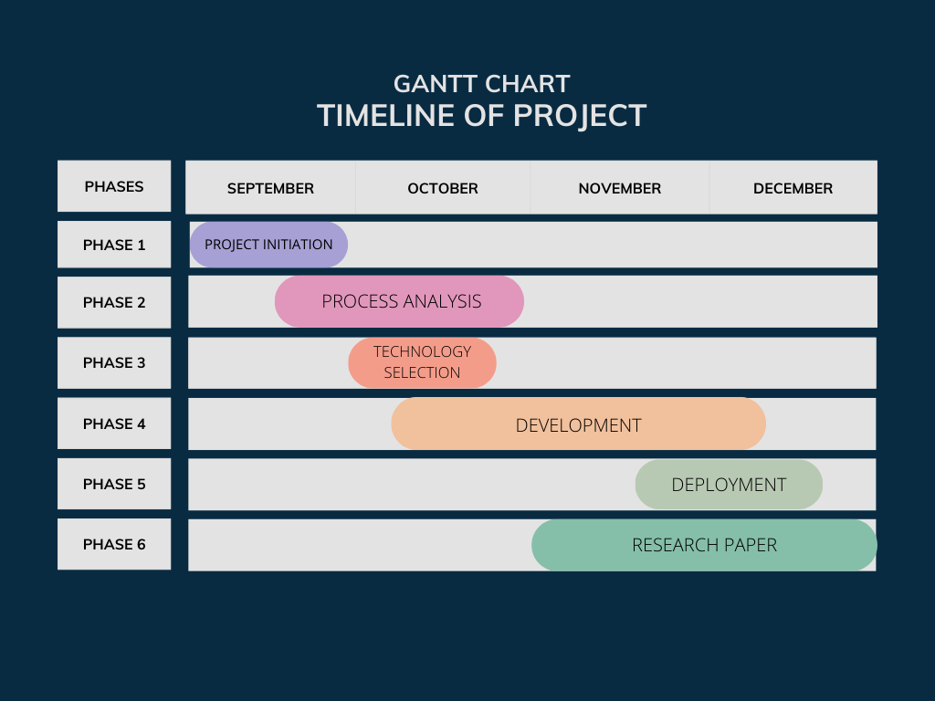

**CHAPTER-8**

**OUTCOMES**

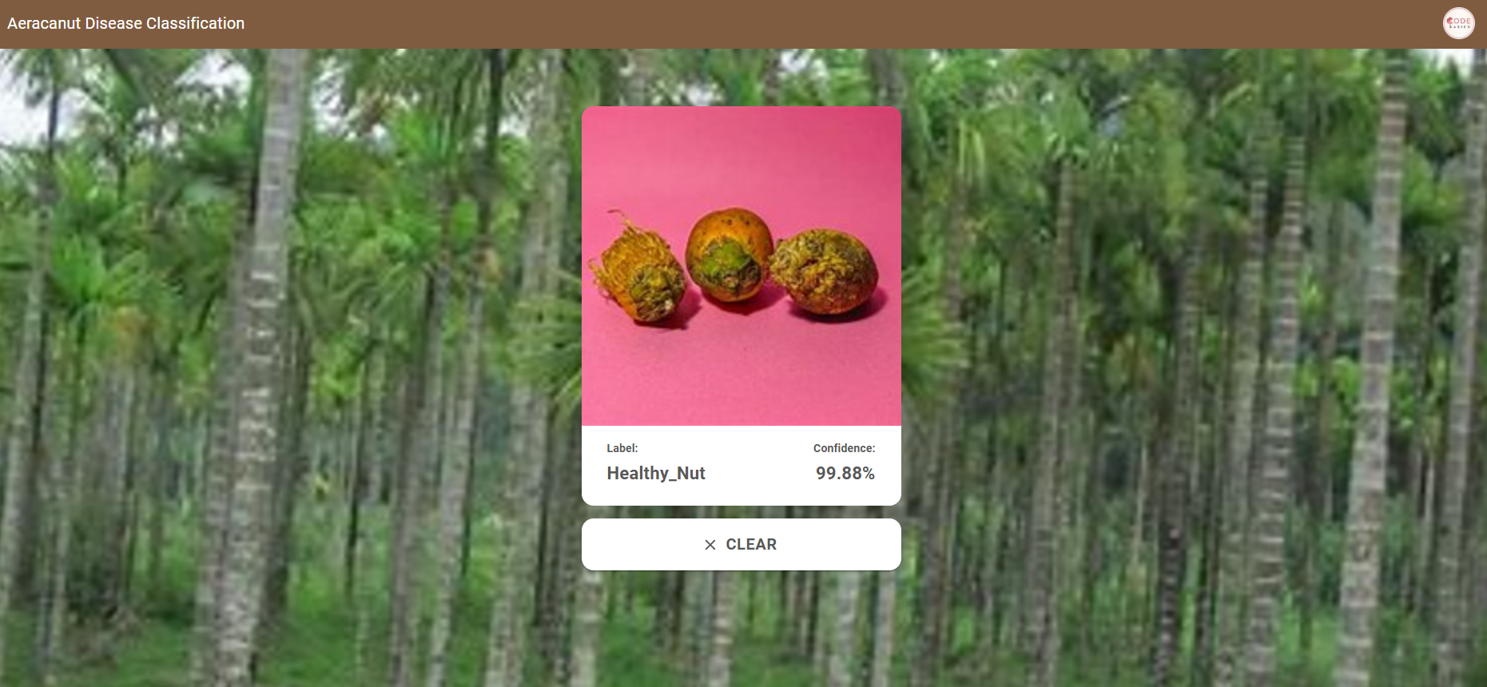

**Fig 1.2**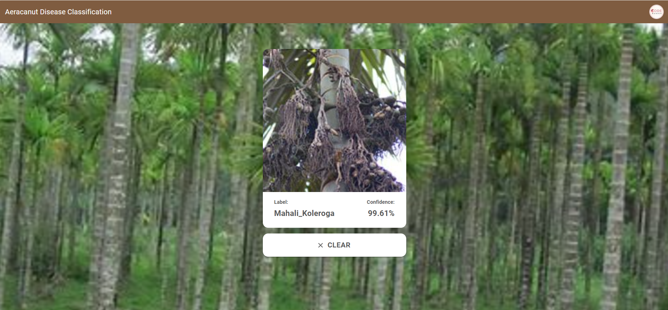

**Fig 1.3**

**CHAPTER-9**

**RESULTS AND DISCUSSIONS**

Since traditional disease detection techniques are labour intensive and highly specialised, learning how to use them effectively can be difficult. As a result, the majority of conventional techniques typically lead to late interventions on plant health. A recent significant advancement in software systems designed especially to forecast and detect diseases affecting arecanut plants can be attributed to these persistent obstacles and hurdles. These cutting-edge solutions leverage the latest developments in artificial intelligence, machine learning, and image processing, which have demonstrated great promise in enhancing disease management and prevention strategies.

Developing and providing an automated system that is not only very effective but also simple for farmers and agricultural specialists to use is the goal of the Arecanut plant disease prediction software project. They can better detect possible diseases that damage Arecanut plants before they become severe thanks to this cutting-edge system, which enables the system to act quickly for efficient crop management. The technology uses the most sophisticated algorithms available to analyse images of the Arecanut plant in great detail in order to achieve this goal. Sophisticated algorithms are especially made to assist in identifying minute alterations in plants that may be signs of disease, as well as predicting the likelihood of disease under the specified circumstances of many physiological and environmental parameters.

According to the results, the software demonstrated a remarkable capacity to categorise various diseases with a remarkable level of accuracy, in fig 1.2 frequently above 90% in situations when it was intended to detect specific diseases using plant photos. Furthermore, the use of convolutional neural networks, or CNNs, was crucial in the observed test accuracy of 99.61% in Fig 1.3 following model training. The model was fed the picture of the leaf as it appears in training with CNN. It displays the likelihood of the diseases found in arecanuts, which are detected by the trained model. For the user's reference, the treatment for the maximum probability disease is also displayed.

Discussions:

An Useful Consequences The agricultural industry can greatly profit from the creation of an automated disease prediction system for arecanut plants, which has numerous practical consequences.

Cost Savings: By eliminating the need for farmers to do time-consuming manual inspections and diagnose problems, this system can greatly reduce labour costs and save time. This is one of its most significant benefits. Additionally, the program reduces expenses by preventing the abuse of pesticides because its early detection capacity enables focused pest control, allowing the farmer to apply more effective and efficient treatments.

Sustainability: By improving agricultural output through improved disease management precision, the software encourages sustainability in farming. By lowering the amount of pesticide residue in the soil and water, the software promotes environmentally friendly farming practices and avoids the waste of chemical treatments.   
  
Increased Crop Yield: Early disease detection and management improves crop health and yields improved quality during the arecanut harvest season.

Image Quality: The precision and accuracy of the disease prediction have a significant impact on the quality of the user-uploaded images. Poorly lit, low-resolution, or unclear images can result in inaccurate diagnosis or even potentially overlooked symptoms that could be crucial. For the program to work correctly and produce the most dependable results, access to high-quality photos is therefore very essential.

Environmental Variability: Certain diseases are prone to exhibit symptoms that are significantly impacted by particular environmental factors in their surroundings. Attempting to forecast diseases based only on photos and environmental data might occasionally result in inaccurate findings, which could appear as false positives or negatives, especially in areas where weather patterns change regularly and irregularly. More investigation and adjustment are needed to take into account geographical variations in order to improve the accuracy of such forecasts.

Diversity of Data: To improve the overall robustness and effectiveness of the software, the training dataset for machine learning models should be varied. Numerous plant conditions, plant diseases, and geographic locations should all be covered in this dataset. However, gathering, organising, and curating such a large and diverse collection of data is difficult and time-consuming.

Cooperation with specialists: If a determined effort were made to collaborate with local extension agencies and agricultural specialists who are knowledgeable about the complexities of farming, the software may see major upgrades and advancements. Through such collaboration, the disease prediction models could be more effectively customised to meet the unique needs and requirements of different regions and to align with the diverse farming practices found across different agricultural landscapes.

Extension to Other Crops: Despite the fact that the application was first created just for arecanut plants, it should be noted that the enabling technologies employed within the system would be applicable and flexible enough to anticipate diseases in a variety of other crops. Such adaptability will further boost the system's scalability, enabling it to be used for a wider range of agro-industrial domains and optimising the usefulness and potential of the specified application throughout all of agriculture.

**CHAPTER-10**

**CONCLUSION**

This article employs Convolutional Neural Networks to detect ailments in Arecanut, including its leaves and stem. Experimentation is undertaken with diseased   
A healthy arecanut picture dataset with 620 photos. The input image is pre-processed, then features are extracted, trained, and classified. The suggested system detects and treats arecanut ailments such as Mahali, stem haemorrhage, and yellow leaf spot.   
Experimental results vary in illness identification accuracy based on image quality and disease stage. The system's overall accuracy is estimated at 88.46%. This approach promotes smart farming and helps farmers make more informed yield decisions.

The experiment highlights the possibility for incorporating technology into agriculture to address issues such as late disease diagnosis and excessive pesticide use. While the system has performed admirably in controlled situations, continued improvements in data collecting, image quality, and environmental aspects will increase its robustness and accuracy in real-world applications. Overall, this is a step towards precision agriculture by providing farmers with a user-friendly, cost-effective, and scalable technology to help them efficiently manage Arecanut plant diseases. When the program is further developed and widely implemented in Arecanut and other crops, it is expected to transform the way disease management is done.

**REFERENCES**

[1] Dhanuja K C. Image Processing Technology for Areca Nut Disease Detection. Journal of Engineering Research International 2020.

[2] Swathy Ann Sam, Siya Elizebeth Varghese, Pooja Murali, Sonu Joseph John, Dr. Anju Pratap. Time saving malady expert system in plant leaf using CNN, 2020, Volume 13, Issue No 3.

[3] Mallaiah, Suresha, Danti, Ajit, and Narasimhamurthy, S. Diseased Arecanut Classification Using Texture Features. International Computer Journal Applications, 2014.

[4] Mr. Ashish Nage, Prof. V. R. Raut, Python-Based Plant Leaf Disease Detection and Identification, International Journal of Engineering IJERT (Research & Technology), Volume 08, Issue 05, 2019.

[5] Smart Farming: Detecting Pomegranate Disease Through Image Processing, Manisha Bhange, H.A. Hingoliwala, Procedia Computer Science,

Volume 58, 2015, Pages ISSN 1877-0509, 280-288.

[6] MG Anandhakrishnan Joel Hanson, Annette Joy, Jeri Francis, Convolutional Neural Network and Deep Learning for Plant Leaf Disease Detection, March 2017, Volume 7, Issue No. 3, International Journal of Engineering Science and Computing.

**APPENDIX-A**

**PSUEDOCODE**

1. Load dataset of arecanut leaf images (healthy and diseased)

2. Preprocess the images:

- Resize images to a fixed size (e.g., 224x224)

- Normalize pixel values (scale to [0,1])

- Augment images (optional, for better generalization)

3. Split the dataset into training, validation, and test sets

4. Define the CNN model:

- Input layer: Image size (224x224x3)

- Convolutional Layer 1: Apply filters (e.g., 32 filters, 3x3 kernel)

- Max Pooling Layer 1: Reduce spatial dimensions

- Convolutional Layer 2: Apply more filters (e.g., 64 filters, 3x3 kernel)

- Max Pooling Layer 2: Reduce dimensions again

- Flatten: Convert 2D features to 1D vector

- Fully Connected Layer: Dense layer (e.g., 128 units)

- Output Layer: Sigmoid activation for binary classification (healthy or diseased)

5. Compile the model with an appropriate loss function (binary cross entropy) and optimizer (Adam)

6. Train the model using the training dataset

7. Validate the model using the validation dataset during training

8. Evaluate the model on the test dataset to check accuracy and performance

9. Use the trained model to make predictions on new arecanut leaf images

10. Output the prediction (e.g., 'Disease Detected' or 'Healthy')

**APPENDIX-B**

**SCREENSHOTS**

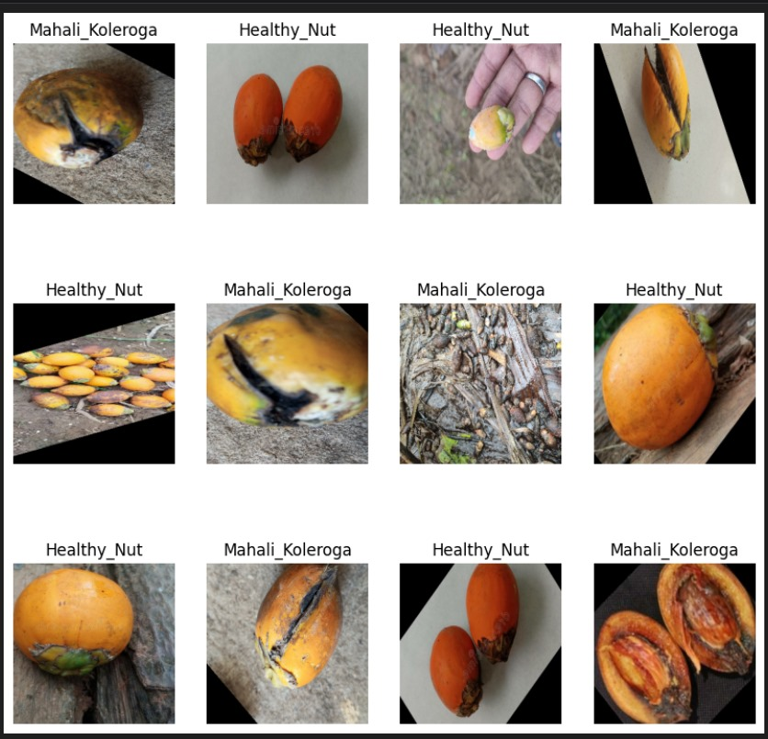

­­­­­­­­­­­­ **Fig 1.4 Mahali Koleroga and Healthy Nut**

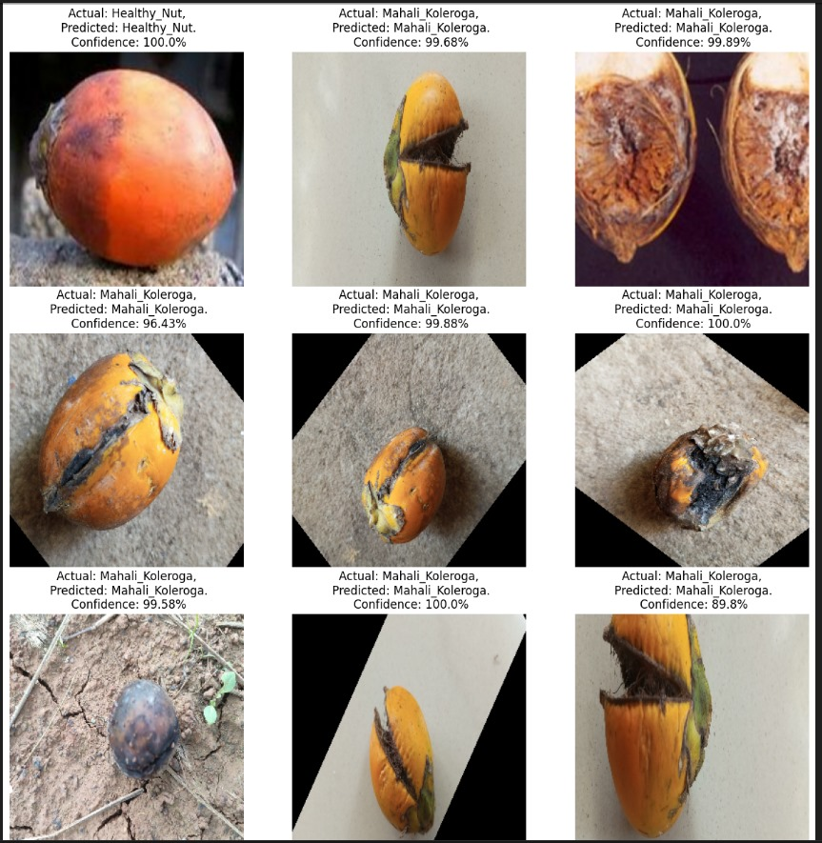

**Fig 1.5 Disease Nut with Confidence Level**

**APPENDIX-C**

**ENCLOSURES**

1. **Journal publication/Conference Paper Presented Certificates of all students.**











1. **Include certificate(s) of any Achievement/Award won in any project-related event.**
2. **Similarity Index / Plagiarism Check report clearly showing the Percentage (%). No need for a page-wise explanation.**

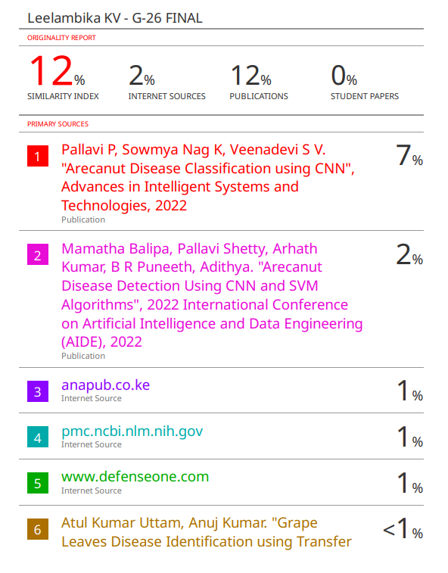

1. **Details of mapping the project with the Sustainable Development Goals (SDGs).**



**SDG 8: Decent Work and Economic Growth:**

* **Increased Efficiency:** Automation can lead to increased efficiency in customer support, which can create more jobs in higher-skilled roles and promote economic growth.
* **Reduced Labor Costs:** Automating repetitive tasks can reduce labor costs for businesses, which can allow them to invest more in employee development or other areas.

**SDG 9: Industry, Innovation, and Infrastructure:**

* **Technological Advancement:** The idea utilizes technology- RPA to achieve business process change, thereby assisting in the advancements of technology.

**SDG 11. Sustainable Cities and Communities**

* Improved Service Delivery for the city and community is seen as business offers better service if it increases their customer service efficacy.

**SDG 12 Responsible Consumption and Production**

* **Resource Efficiency:** Automation can reduce the consumption of resources (time, labor) in customer support processes.